Meadow Lodge Care Home

.
.
.
.
.
.
.
.
.

(Meadow Lodge Care Ltd)

Brochure and Service User Guide

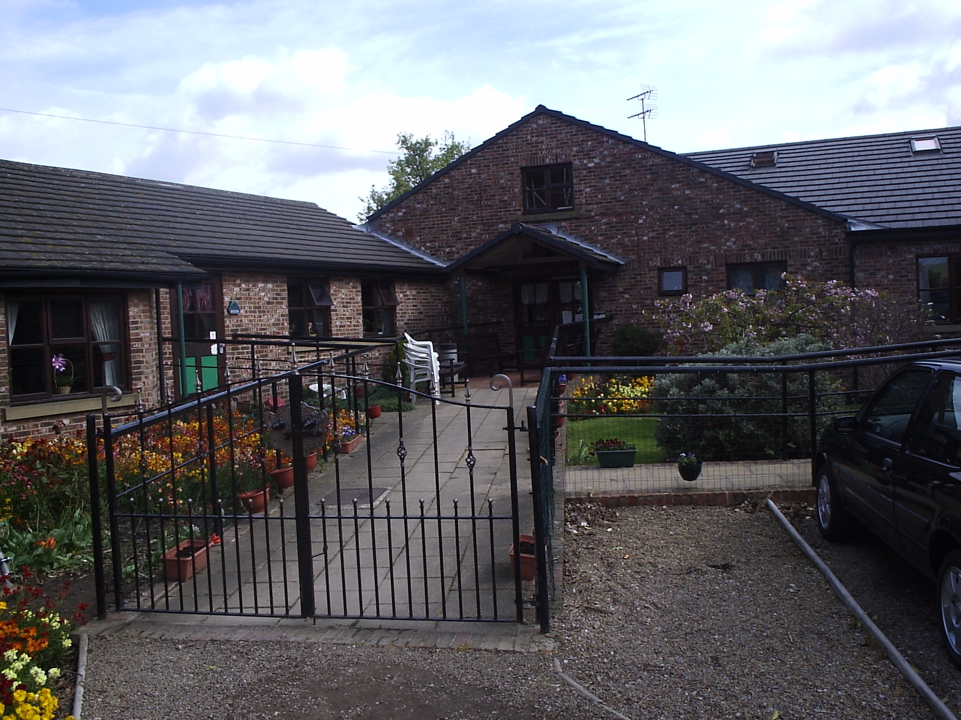

Broach Lane, Kellington, Nr Goole, DN14 OND
Telephone : 01977 662899

Registered Manager : Mrs Lorraine Coultas

Introduction and Aims of the Home

Based in the pleasant village of Kellington, North Yorkshire, Meadow Lodge is a friendly, homely Residential Care Home set in spacious landscaped gardens.
Meadow Lodge provides short or long term care services for people over the age of 65 and specialises in supporting those with dementia.
All residents have a full assessment of their care needs performed and the plan of care which is then prepared is constantly reviewed and updated to reflect any changes to a resident’s condition.
We are committed to enabling our residents to live the life they want, providing them with the support, care and encouragement they need.
We encourage and enable our residents to live as full, interesting and independent a lifestyle as possible.
We are also committed to ensure residents are fully consulted about matters that effect their wellbeing and quality of life.
When you live at Meadow Lodge you can relax in knowing that this is your home for as long as you want.
People are rarely admitted to hospital other than for acute problems and, generally, end of life care is provided at Meadow Lodge.
Services and Facilities
General overview
With the exception of the old farmhouse, which has been altered to modern day standards but retains many of the original features, all the accommodation at Meadow Lodge has been purpose built.
There are fourteen en-suite bedrooms and seven additional bedrooms available to residents.
Smelling fresh and looking clean and tidy, the home is cleaned on a daily basis. We pride ourselves on maintaining the building and environment to a high standard.
There is a large ramped entrance that is south facing and incorporates garden benches and plant displays.

Communal Facilities
We have two lounges, one of which is particularly spacious and is the hub of the friendly home. The main lounge houses a large screen TV and sound system.
There is a separate, south facing dining room which has a sunny outlook and provides a comfortable setting for the interesting and varied meals provided.
A small kitchenette is available for those residents who wish, and are able, to make drinks for themselves.
The wide corridors throughout makes the home feel hotel like; a place for residents to continue to enjoy life and maintain their independence.
In addition to the en suite facilities available in many rooms, the home has three large, assisted bathrooms.

Room Facilities
Most of our rooms have en suite facilities and some offer the chance to share with a companion. We welcome personal furniture and possessions always hoping to give you a home away from home. All rooms have Television Aerial points and private telephone sockets can be installed if requested.
Residents can, if they wish, hold the key to their own rooms.

Meals
Interesting and varied meals for lunch and tea time are provided by specialised catering company. This provision is supplemented by our own catering staff who prepare freshly cooked breakfasts and home baked cakes / buns and other snacks throughout the day.
Choice is offered at every meal, snacks and drinks are available throughout the day and all types of dietary requirements or specialised diets are catered for.
We are happy to assist residents to eat and visitors are welcome to join residents for meals.
We are very proud of the standard of food at the home and offer an open invitation to potential residents and their relatives to come and try for themselves.

A typical weekly menu would look like this:

Garden
Our spacious enclosed garden is a super space to get some fresh air and sit and relax. A summer house provides seating and shelter and mature trees bring together the landscaped features. We also have a potting shed, vegetable plots and flower beds for residents use.

Safety and Specialist Features
A pleasant temperature is maintained throughout the home by central heating with individual thermostat controls along with the correct ventilation.
To keep all residents safe, a full fire detection and alarm system is maintained and fully compliant with all current regulations. Lifting and bathing aids ensure all residents individual needs are catered for and further equipment is provided by an Occupational Therapist and District Nurses as needed.
A passenger lift has been installed in order to take residents to the first floor where needed.
General
All laundry and housekeeping services are included in our fees.
To help our residents maintain their independence we offer an administration support service, for example, typing a letter for a resident.

Staffing

Under the same ownership since 1989 Meadow Lodge has an enviable reputation for providing a high quality service in a caring, competent and professional atmosphere.
Registered Provider
Karen Shann is the owner and registered provider of Meadow Lodge Care Home. She has worked in health and social care since 1975 and also operates Meadow Lodge Home Care Services which is based in Sherburn in Elmet and which cares for clients in their own homes across North Yorkshire and Wakefield.
Registered Manager.
Lorraine Coultas has been the Registered Manager since 2009. Lorraine has NVQ LEVEL 4 in care and holds the registered managers award she has worked in the social care sector since 1996. Lorraine is also qualified to teach moving and handling to other carers and is also a fully qualified NVQ assessor.
Team Leader – Mary Riley.
Mary has NVQ level 3 in care and has worked at Meadow Lodge for over 20 years. Mary was nominated and made it into the final four of Best Care Home Worker in the Great North Care Awards 2008.
Team Leader – Margaret Frackleton.
Margaret has NVQ level 3 in care and has worked at Meadow Lodge for over 10 years.
This group of very senior staff are supported by a very experienced team of carers. All staff are trained as a minimum to comply with the Skills for Health Common Induction Standards Social Care work, but many have qualifications and training which exceed those standards.
Leisure and social activities
Along with our wellbeing personal care activities like hairdressing, shiatsu massage, chiropody and physiotherapy, Meadow Lodge care staff arrange a variety of in house activities on a daily basis. From sing-a-longs to bingo, outings and entertainment evenings, even Tai Chi, our residents are encouraged to enjoy social activities, hobbies and leisure interests.
All residents are encouraged to retain their life skills by participating, for example, in baking, housekeeping or simple maintenance.
Many residents find their social circle increases and they become more active once they join us at Meadow Lodge.
You choose whether you join in or you may prefer to spend time in your room, or just plug in your own laptop, we fully respect that the choice is yours.
A number of residents enjoy spending time in the kitchen helping the cooks baking the cakes that will be served at tea time later that day.
Residents can take advantage of Wi Fi internet access and the use of the home’s laptops whenever they wish.
In addition to selection books kept at the home, a mobile library visits every two weeks. If requested, residents can be assisted to visit the local library.
Relatives and friends are encouraged and welcome to attend any social event at the home. We actively encourage residents to continue with all forms of social contact that they enjoyed before moving into the home and we will try to help you to maintain those if you like!
We still have relatives that visit the home to help with activities even when their loved one is no longer living at Meadow Lodge.
The well maintained garden can be reached directly from the dining room and provides a perfect setting for rest and relaxation. The garden has a summer house and potting shed for the use of residents. There are vegetable plots and extensive flower borders which can be used, or simply admired, by our residents.
Residents can also join in with the care of our chickens, help collect eggs or just be entertained by their antics.
In addition, to help you get out and about, we have transport which has been custom altered to accommodate wheelchairs for outings and appointments.

Medical Care - Qualified Nursing and Care Staff

The GPs and District Nurses from Ashgrove Surgery and others in the primary care team visit on a regular basis. Residents may, of course, retain their own Doctor if this is practical.

Optician and Dentist

We have a visiting optician and dentist for residents who are unable to attend their surgery

Physiotherapy

Can be arranged as necessary after a G.P. referral.

Chiropody

A private chiropodist visits the Home regularly. This service attracts an additional payment to the chiropodist.

Hairdressing

Basic hair care is provided free of charge. A professional hairdresser visits each week and this is charged for separately.

Personal Telephones

Meadow Lodge has a number of telephone lines entering the Home via a digital switchboard. The telephone and fax numbers are 01977-662899 / fax01977-663103

Shopping

Where appropriate we encourage residents to go shopping on their own, with relatives or with a staff member. Where this is difficult staff can assist residents by purchasing goods on their behalf within the necessary safeguards of our Personal Finance Policy and Procedure.

Laundry

Al laundry is undertaken within the Home and is included in the normal fees for service.

Gifts and Signing Legal Documents

The Home’s employees or staff are not permitted to directly accept any gifts, and / or presents from residents or to sign as a witness any legal document which pertains to one of the residents in the home.

Complaints

The Home’s complaints policy is attached at the end of this brochure

Visitors

Meadow Lodge is considered to be the resident’s Home and so, subject to the resident’s wishes, visitors are generally welcome at any time within reason.

Residents can usually receive visitors in their own room or in one of the lounges or, outside meal times, in one of the dining rooms.

Visitors wishing to take residents off the premises should speak to the Senior Member of Staff on duty first to ensure that any medication can be provided and that the trip out is within the capacity of the resident.

Relatives and friends are encouraged to attend social events such as resident’s Christmas Party, Summer Fair, entertainment evenings etc.

If you require any further information on Meadow Lodge please do not hesitate to contact us to arrange a visit.

Meadow Lodge Care Ltd
Complaints Policy and Procedure

- Policy
Meadow Lodge Care Ltd believes that all service users, relatives, representatives and members of staff have a right to inform us of any problems or complaints they may have.
We are always looking to improve our services and all comments, suggestions or complaints, regardless of how small they may appear, will be treated seriously and used to improve the services we provide.

- Complaints Procedure
- Stage 1
We hope that the service provided by Meadow Lodge Care Ltd will always meet with your satisfaction. However should you find the need to complain about any aspect of the service you receive please let us know by telling one of the members of staff on duty.
We hope that in this discussion the problem can be resolved but should this not be the case please ask to see or speak to one of the senior carers.
Stage 2
If, after speaking to one of the senior carers, you remain unhappy you can make a formal complaint. At this time you may be asked to record your complaint in writing, perhaps with the assistance of a family relative or friend. If you need further help we will be pleased to recommend an independent person called an ‘ advocate ‘ who is not a member of this organization and will be able to assist you.
All written complaints will be recorded and acknowledged by the Registered Manager or their nominated deputy within 2 working days of receiving the complaint.
The Registered Manager will try to resolve the problem as quickly as possible and you should receive a written answer to your complaint, confirming any action that has been taken, within 28 days.
- Stage 3
If the Registered Manager has not been able to rectify the complaint and you are still dissatisfied you can contact your local Social Services Department (if your care is funded by the Local Authority) the or Local Government Obmudsman (if you fund your own care or the local Social Services Department has been unable to help)
You may also contact the Care Quality Commission ( the CQC) which is the independent regulator of health and social care in England. The CQC website can be found here
http://www.cqc.org.uk/

You can contact the CQC the England based National Customer Service Centre:
Telephone: 03000 616161
Fax: 03000 616171

Or write to
CQC National Customer Service Centre
Citygate
Gallowgate
Newcastle upon Tyne
NE1 4PA

MEADOW LODGE RESIDENTIAL HOME
TERMS AND CONDITIONS OF RESIDENCY

1 AGREEMENT

This agreement is made between:

Meadow Lodge Care Ltd

And

Date

This contract is a legal agreement which sets out the terms and conditions of residency at the home.

The room to be occupied is ……………………………

2 INTRODUCTION

The aim of management and staff at Meadow Lodge is to provide a comfortable and relaxed home suited to your individual requirements. We undertake to consult you and / or your family together with any others acting in your interests in all matters to do with your well-being.

The home is designed to be your home from which you can run your life, do the things you want to do and make the most of your abilities. The home will do everything reasonably possible to accommodate and help you pursue your interests, hobbies and other activities.

Your room is fitted with a suitable lock and will be accessible to staff in an emergency. You will be provided with keys taking into account any assessed risks.

3 TRIAL PERIOD

The decision to become a resident is an important one and for this reason the first four weeks of your stay should be considered a trial period. If either you or the home do not wish to continue your residence then your residence will terminate at the end of the trial period. No notice will be required during the trial period.

4 FEES

The fee is ---------- per week
This fee covers the cost of personal care, basic hair care, food, accommodation, heat, light, and so on. Professional hairdressing and chiropody can be arranged for residents at their own expense.

5 ABSENCES

When a person vacates their room temporarily (e.g. for a holiday or hospital admission) a reduction of 5% will be made in the fees payable.
.

6 PERSONAL EFFECTS (incl. money and furniture)

You are welcome to bring your own furniture with you although, of course, if you wish, we will provide everything you need.

You must tell us about any electrical items that you bring with you so that we can make sure that they are safe to use. If you have a television, you do not need to buy a separate ‘full fee’ licence. The manager will provide details of the Concessionary TV Licence Scheme.
You can deposit your valuables with us (including cash) for safekeeping. You might wish to leave cheque books, pension books or other savings books with us also. If you no longer wish to handle your own financial affairs (or are unable to), you should arrange for someone to do this. The manager and staff are not normally allowed to do this without prior written permission.

7 CARE STAFF

The home employs trained care assistants under the direction of a professionally trained and qualified manager. Sufficient staff will be available at all times to accommodate residents’ requirements. Your views will be sought in order that the level of care you require can be agreed.

All of our staff are trained to care for you, to safeguard your rights and to respect your dignity and independence. If you are not satisfied with the conduct of staff please raise your concerns with the manager. Please see the complaints policy also.

8 OUTINGS

Visitors are encouraged to take residents out although they must tell the person in charge that they intend to do so. We can accept no responsibility for the resident during such outings.

9 ASSESSMENT / CARE PLANNING AND REVIEW

Our aim is to plan your care based upon an assessment of your needs. The home will adopt procedures to review your own situation regularly with you, your family, the managers at the home and other relevant professionals involved in your care.

11 MEDICATION

Prescribed medication is the resident's private property. In cases where the resident is unable to look after their own medicine, the manager will make arrangements for the supervision and administration of such medication. The home has a contract with the local pharmacist for the supply and management of medications..

12 TERMINATION OF THIS AGREEMENT

One calendar months notice or payment in lieu will be required should a resident decide to leave the home (except when the departure is due to the death or sudden illness of the resident, in which case no such notice will be required). Although it is the aim of the home to care for residents for the rest of their lives there are some occasions where the care needs of the resident cannot be provided in a residential home. If a resident has to leave because the home is unable to provide for their needs four weeks’ notice will be given.

13 DEATH

In the event of the death of a client the next of kin and / or the legal representative will be informed.

14 REGISTRATION

The home is registered as a Care Home by the Care Quality Commission ( the CQC) the body responsible for ensuring that standards are maintained. Further information is available at
http://www.cqc.org.uk/

15 COMPLAINTS

Residents or their representatives should in the first instance discuss any complaints with the manager or senior care staff on duty if they are not satisfied. Please see the attached complaints policy for further information about what you can do if you remain dissatisfied.

16 SUGGESTIONS

The home regularly reviews its procedures to improve its services. Your views will be sought and if you have any suggestions with regard to the running of the home these will be welcomed.

17 CONFIDENTIALITY

All personal records relating to you which are kept by the home will be kept strictly private and confidential. You are entitled to see such records should you wish to do so.

18 INSURANCE

The home is properly insured by CHIS insurance, a national company which specialises in services for care homes/

19 DOCUMENTS

The manager will give you copies of:
- The Resident’s Charter of Rights.
- The Complaints Policy

Signed on behalf of Meadow Lodge ………………………………

Date…………..

Signed on behalf of ………………………………

Relationship to ………………………………

Date…………………………………………..

MEADOW LODGE RESIDENTIAL HOME
EQUAL OPPPORTUNITIES POLICY

Principles

We at Meadow Lodge are committed to providing equality of opportunity for staff in our employment and residents who receive our services, and will abide by the following principles:

- As an employer we accept the statutory requirements laid down in the Race Relations Act 1976, the Sex Discrimination Act 1975 (as amended) and the Disability Discrimination Act 1995. In addition we also include within these principles sexual orientation and age.

- It is unlawful for an employer or employee to discriminate against or to treat an individual differently on the grounds of colour, race, ethnic origin, marital status, nationality, gender or disability. We will ensure that no one who applies for a job or staff employed by us receives less favourable treatment on any of these grounds.

- We are committed to the active promotion of equal opportunity in our services, and we recognise that the achievement of equal opportunities will require the participation of all staff and a commitment to this policy.

Residents

In our services to residents we will ensure that:

- All residents are treated as individuals.
- We recognize and have a positive attitude to the diverse religious or cultural beliefs and customs of residents.
- When planning and delivering care to residents our staff will take into account the different and special needs of residents.

Training

We will as part of our training programme ensure that staff are aware of their responsibilities in promoting and achieving equal opportunities.

Signed ____________________ Manager

Date ____/____/____

